PIZZA SALES ANALYST

SQL QUERYS

1. FOR UNDERSTAND ALL SALES DATA COLUMNS AND OTHERS .

* describe pizza_sales;

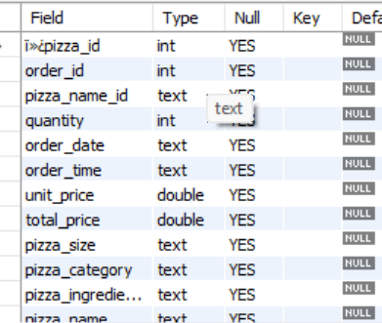

1. TOTAL REVENUE

* select round (sum(total_price) ,2) as "Total Ravenue" from pizza_sales;

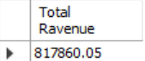

1. AVG ORDER VALUE

* select round(sum(total_price)/count(distinct(order_id)) ,2)as "Avg Order Value" from pizza_sales;

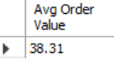

1. TOTAL PRICE

* select sum(quantity) as "Total Pizza"from pizza_sales;

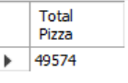

1. TOTAL ORDER

* select count(distinct(order_id)) as "Total Order" from pizza_sales;

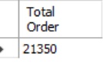

1. AVG PIZZA PER ORDER

* select round(sum(quantity)/ count(distinct(order_id)),2)as "Avg Pizza Per Order" from pizza_sales;
* 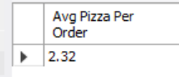

1. DAILY TREND

* SELECT DAYNAME(STR_TO_DATE(order_date, '%Y-%m-%d')) AS DayName,

COUNT(DISTINCT order_id) AS total_orders

FROM pizza_sales

WHERE order_date IS NOT NULL

GROUP BY DAYNAME(STR_TO_DATE(order_date, '%Y-%m-%d'));

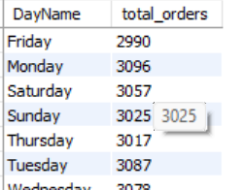

1. MONTHLY TREND

* SELECT monthname(STR_TO_DATE(order_date, '%Y-%m-%d')) AS DayName,

COUNT(DISTINCT order_id) AS total_orders

FROM pizza_sales

WHERE order_date IS NOT NULL

GROUP BY monthname(STR_TO_DATE(order_date, '%Y-%m-%d'));

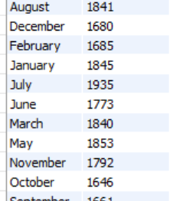

1. % OF SALES BY CATEGORY

* select pizza_category,sum(total_price)*100/(select sum(total_price) from pizza_sales) as "% of sales by category" from pizza_sales

group by pizza_category order by sum(total_price)*100/sum(total_price) desc;

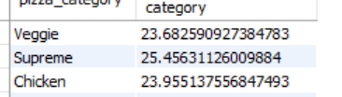

1. % OF SALES BY SIZE

* select pizza_size,sum(total_price)*100/(select sum(total_price) from pizza_sales)

as "% of sales by size " from pizza_sales

group by pizza_size order by sum(total_price)*100/sum(total_price) desc;

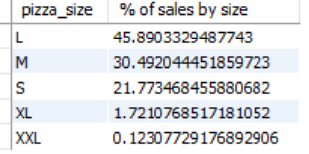

1. TOTAL PIZZA SOLD BY CATEGORY

* select pizza_category,sum(quantity) "total pizza sold by category"

from pizza_sales group by pizza_category order by sum(quantity) desc ;

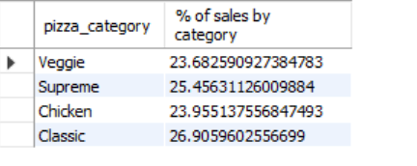

1. TOP 5 PIZZA NAME WHO MOSTLY SOLD

* select pizza_name , round(sum(total_price),2) as total_price , sum(quantity), count(distinct order_id)

from pizza_sales group by pizza_name order by round(sum(total_price),2)

desc limit 5;

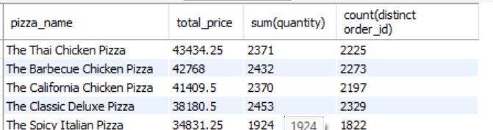

1. TOP 5 PIZZA NAME WHO WORSTLY SOLD

* select pizza_name , round(sum(total_price),2) as total_price , sum(quantity), count(distinct order_id)

from pizza_sales group by pizza_name order by round(sum(total_price),2)

asc limit 5;

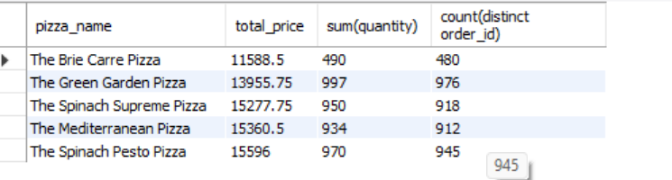

HERE IS SQL QUARYS FOR ALL THE ANALYSIS OF PIZZA SALES AND WE ARE SOME CRETE KPI TO UNDERSTAND ALL REVANUE AND TOTAL ORDER PLASED LIKE SO CREATE DASHBOARD IN POWERBI